STEREO HEADSET
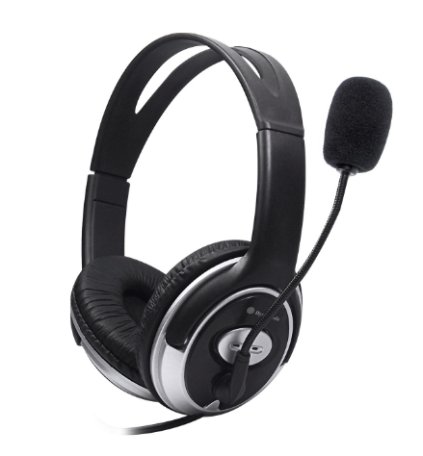
DH-660-USB

Descrption:

Perfect headset for a disturbance- free experience,maximum comfort and superb performance. Excellent for interactive games,internet telephony and personal CD music enjoyment.

.SPECIFICATIONS:
- SPECIFICATIONS:
- Characters: Headphone with microphone
- Loudspeaker diameter: Ф40mm
- Earphone sensibility: 102dB/mw
- Resistance: 32Q
- Microphone: 6x5/-52dB+2dB
- Signal wire: 2.3m
- USB diameter: USB

SPEZIFIKATION:
- Buchstaben: Kopfhorer mit Mikrophon
- Lautsprecherdurchmesser: Ф40mm
- Kopfhorer Empfindlichkeit: 102dB/mw
- Widerstand: 322
- Mikrophon: 6x5/-52dB+2dB
- Signalader: 2.3m
- USB diameter: USB

SPECIFICHE:
- Caratteri: Cuffia con il microfono
- Diametro dell'altoparlante: Ф40mm
- Sensibilita del trasduttore auricolare: 102dB/mw
- Resistenza: 32Q
- Microfono: 6x5/- 52dB+2dB
- L egare di segnale: 2.3m
- USB diameter: USB

ESPECIFICACION:
- Caracteres: Auricular con el microfono
- Diametro del altavoz: Ф40mm
- Sensibilidad del auricular: 102dB/mw
- Resistencia: 329
- Microfono: 6x5/-52dB+2dB
- Alambre de senal: 2.3m
USB diameter: USB

CARACTERISTIQUES:
- Caracteres : Ecouteur avec le microphone
- Diametre de haut-parleur: Ф40mm
- Sensibilite d'ecouteur: 102dB/mw
- Resistance: 329
- Microphone: 6x5/- 52dB+2dB
- Fil de signal: 2.3m
- USB diameter: USB

CNELVФVKAL lVV:
- XapaktepncTuka: HaywHnk C MMKpOФ0HOM
- AmameTp「pomkorobopnteng: Ф40mm
- 4yBCTBUTeNbHOCTb: 102dB/mw
- Hanpaxehve: 322
- MnkpoqoH: 6x5/-52dB+2dB
- NpoBoA CurHana: 2.3m
- USB diameter: USB

